

**(Affiliated to Tribhuvan University)**

**Advanced Java Programming**

**Lab 004**

**Packaging and Multithreading**

|  |  |
| --- | --- |
|  |  |
|  |  |
|  |  |

**Submitted by:**

Abhinna Ojha, 20788/075

BSc. CSIT - VII

**Submitted to:**

Mr. Krishna Pandey

Department of CSIT

# Interfaces

## Write a program to define a queue interface and have insert and delete methods in the interface. Implement these methods in a class.

/*

Title:

Interfaces

Description:

Write a program to define a queue interface and have insert and delete methods

in the interface. Implement these methods in a class.

Date modified; Author(s); Modification details

2022-12-28; abhinna; Created the program

*/

import java.util.Scanner;

// class of individual members of queue

class QueueValue {

int value;

QueueValue next;

public QueueValue(int value) {

this.value = value;

next = null;

} // QueueValue(int value)

} // class QueueValue

// an interface to implement insert and delete methods

interface IQueue {

void insert(QueueValue q);

void delete();

} // interface IQueue

// implementation of interface on class

class Queue implements IQueue {

// front and back pointers of the queue to keep track of the front and back of queue

// for insert and delete

QueueValue front, back;

// initialising queue to be empty queue at the beginning

public Queue() {

front = null;

back = null;

} // public Queue()

// overriding interface methods

@Override

public void insert(QueueValue q) {

// if front = null, it is an empty queue

// so, front and back are the newly inserted value

if (front == null) {

front = q;

back = q;

} // if (front == null)

else {

// replace the null on next pointer of current back to newly inserted queue value

// then replace the current back value with newly inserted queue value

// back.next = q; back = q; is also viable

back.next = q;

back = back.next;

} // else of if (front == null)

} // public void insert(QueueValue q)

@Override

public void delete() {

// to delete, just replace the front pointer with the next of front so front changes

// front defines the start of queue, so the old front cannot be accessed, thus is deleted

front = front.next;

// if front = null then queue becomes empty so assign back as null too

if (front == null) {

back = null;

} // if (front == null)

} // public void delete()

public void display() {

QueueValue i = front;

// displaying values from front

// once the next pointer of a value is null, queue has reached its end

// also, once i = back the queue reaches is end, so it can be implemented that way too

while (i != null) {

System.out.println(i.value);

i = i.next;

} // while (i != null)

} // public void display()

} // class Queue implements IQueue

// main class that has the main

public class Q1Interfaces {

public static void main(String[] args) {

// creating array of queue values for easier manipulation

// making array of large size to avoid dynamic sizing for now

QueueValue[] queueValue = new QueueValue[100];

// initiating a counter to point to array position, updates on insert only

int x = 0;

// creating the queue

Queue queue = new Queue();

// defining infinite flag for while based infinite loop

boolean infiniteFlag = true;

// infinite loop until exit is hit

while (infiniteFlag) {

System.out.println("\n1.insert");

System.out.println("2.delete");

System.out.println("3.display");

System.out.println("0.exit");

System.out.print("Make your choice: ");

int choice;

Scanner scanner = new Scanner(System.in);

// scanner may have exception if user inputs character or decimals instead of integers

try {

choice = Integer.parseInt(scanner.nextLine());

switch (choice) {

case 0 ->

infiniteFlag = false;

case 1 -> {

System.out.print("Enter integer to insert: ");

// try for input of value for QueueValue(value)

try {

int value = Integer.parseInt(scanner.nextLine());

queueValue[x] = new QueueValue(value);

queue.insert(queueValue[x]);

x++;

} // try of value for QueueValue(value)

catch (Exception exception) {

System.out.println("Invalid input");

} // catch

} // case 1

case 2 ->

queue.delete();

// case 2

case 3 ->

queue.display();

// case 3

} // switch (choice)

} // try of choice

catch (Exception exception) {

System.out.println("Invalid choice.");

} // catch (Exception exception)

} // while (infiniteFlag)

} // public static void main(String[] args)

} // public class Q1Interfaces

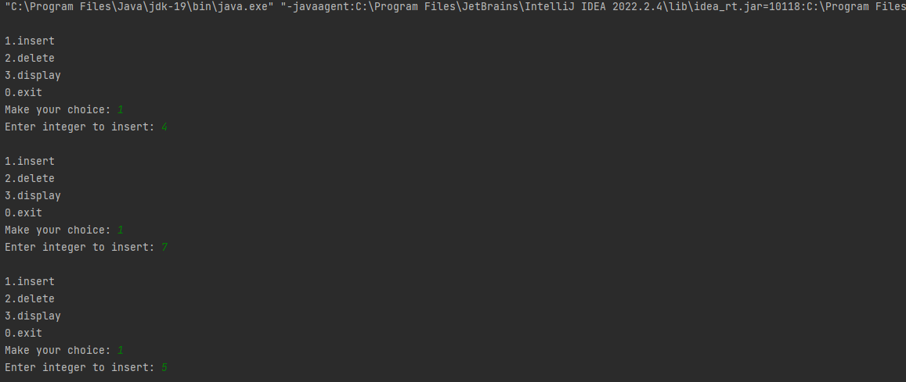

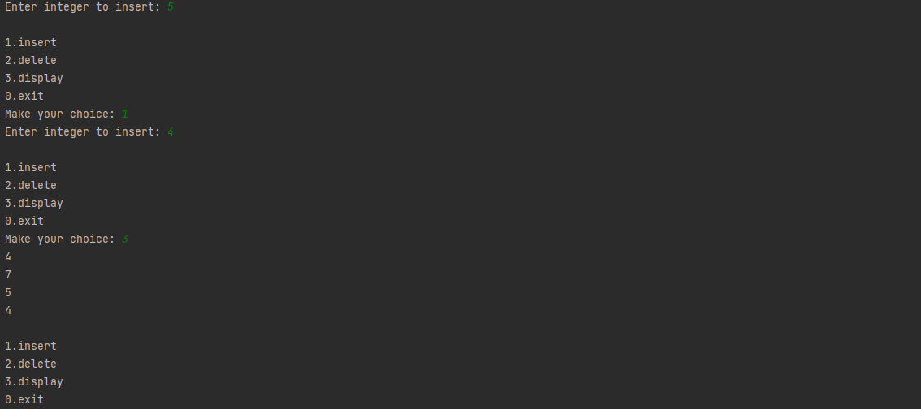

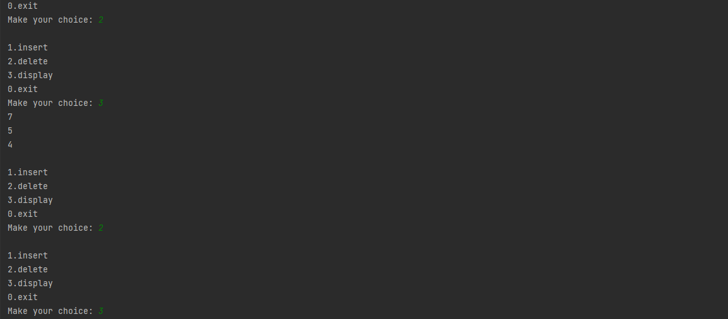

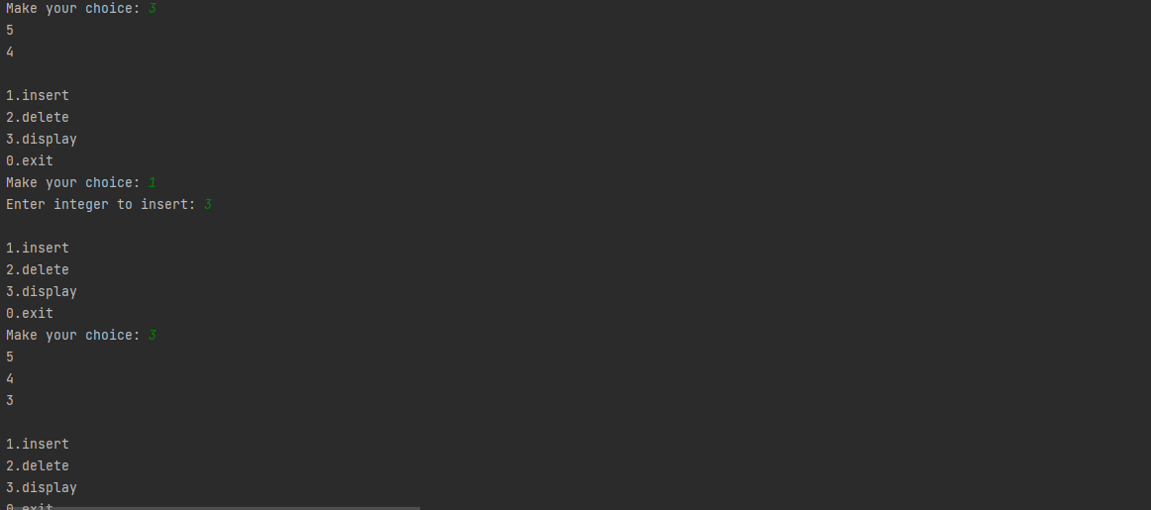

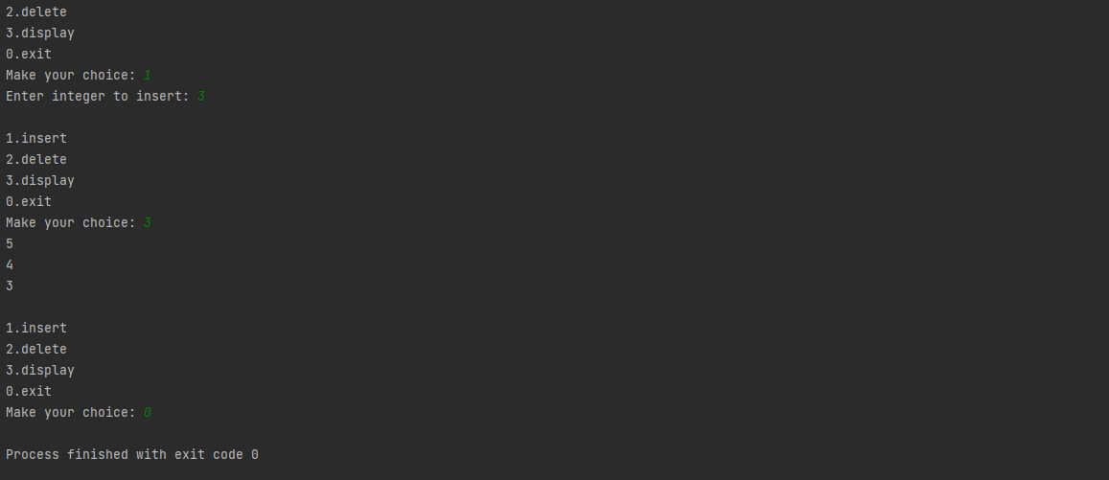

# Packages

## Write a program to define functions for subtract, multiply, divide, factorial and reversing the digits of a number in a package, import this class in another package and use all the methods defined in the primary package.

/*

Title:

Packages

Description:

Write a program to define functions for subtract, multiply, divide, factorial and

reversing the digits of a number in a package, import this class in another package

and use all the methods defined in the primary package.

Date modified; Author(s); Modification details

2022-12-28; abhinna; Created the program

*/

// importing the package to use

import com.Lab004.ArithmeticOperations.*;

import java.util.Scanner;

public class Q2Packages {

public static void main(String[] args) {

// flag for infinite loop

boolean infiniteFlag = true;

while (infiniteFlag){

System.out.println("\n1. Subtract");

System.out.println("2. Multiply");

System.out.println("3. Divide");

System.out.println("4. Factorial");

System.out.println("5. Reverse digits");

System.out.println("0. Exit");

System.out.print("Make your choice: ");

int choice;

Scanner scanner = new Scanner(System.in);

// scanner is for integer only

try {

choice = Integer.parseInt(scanner.nextLine());

switch (choice) {

case 0 -> infiniteFlag = false;

// case 0

// Subtract 2 numbers

case 1 -> {

// scanner for double only

try {

System.out.print("\nEnter a for a - b: ");

double a = Double.parseDouble(scanner.nextLine());

System.out.print("\nEnter b for a - b: ");

double b = Double.parseDouble(scanner.nextLine());

System.out.println(a + " - " + b + " = " + ArithmeticOperations.subtract(a, b));

} // try

catch (Exception exception) {

System.out.println("Error in input.");

} // catch

} // case 1

// Multiply 2 numbers

case 2 -> {

// scanner for double only

try {

System.out.print("\nEnter a for a * b: ");

double a = Double.parseDouble(scanner.nextLine());

System.out.print("\nEnter b for a * b: ");

double b = Double.parseDouble(scanner.nextLine());

System.out.println(a + " * " + b + " = " + ArithmeticOperations.multiply(a, b));

} // try

catch (Exception exception) {

System.out.println("Error in input.");

} // catch

} // case 2

// Multiply 2 numbers

case 3 -> {

// scanner for double only

try {

System.out.print("\nEnter a for a / b: ");

double a = Double.parseDouble(scanner.nextLine());

System.out.print("\nEnter b for a / b: ");

double b = Double.parseDouble(scanner.nextLine());

// error handling for divide by 0 by not allowing the error state to reach

if (b == 0) {

System.out.println("Divide by 0 error");

} // if (b == 0)

else {

System.out.println(a + " / " + b + " = " + ArithmeticOperations.divide(a, b));

} // else of if (b == 0)

} // try

catch (Exception exception) {

System.out.println("Error in input.");

} // catch

} // case 3

// Factorial

case 4 -> {

// scanner for int only

try {

System.out.print("\nEnter a for a!: ");

int a = Integer.parseInt(scanner.nextLine());

// error handling for -ve numbers by not allowing the error state to reach

if (a < 0) {

System.out.println("Factorial is only allowed for +ve numbers");

} // if (a < 0)

else {

System.out.println(a + "! " + " = " + ArithmeticOperations.factorial(a));

} // else of if (a < 0)

} // try

catch (Exception exception) {

System.out.println("Error in input.");

} // catch

} // case 4

// Reverse

case 5 -> {

// scanner for int only

try {

System.out.print("\nEnter a for a's reverse digits: ");

int a = Integer.parseInt(scanner.nextLine());

// error handling for -ve numbers by not allowing the error state to reach

if (a < 0) {

System.out.println("Reverse is only allowed for +ve numbers");

} // if (a < 0)

else {

System.out.println(a + "'s reverse " + " is " + ArithmeticOperations.reverse(a));

} // else of if (a < 0)

} // try

catch (Exception exception) {

System.out.println("Error in input.");

} // catch

} // case 5

} // switch (choice)

} // try

catch (Exception exception) {

System.out.println("Error in input.");

} // catch

} // while (infiniteFlag)

} // public static void main(String[] args)

} // public class Q2Packages

#### com.Lab004.ArithmeticOperations

package com.Lab004.ArithmeticOperations;

public class ArithmeticOperations {

// all methods are made static so that they can be used without instantiation

// subtract operation

public static double subtract(double a, double b) {

return (a - b);

} // public double subtract(double a, double b)

// multiply operation

public static double multiply(double a, double b) {

return (a * b);

} // public double multiply(double a, double b)

// divide operation

public static double divide(double a, double b) {

return (a / b);

} // public double divide(double a, double b)

// factorial of a number

public static double factorial(int a) {

double fact = 1;

if (a != 0 && a != 1) {

for (int i = 1; i <= a; i++) {

fact *= i;

} // for (int i = 0; i <= a; i++)

} // if (a == 0 || a == 1)

return fact;

} // public double factorial(int a)

// reverse digits of number

public static int reverse(int a) {

int rev = 0, x = a;

while (x != 0) {

rev = rev * 10 + x % 10;

x /= 10;

} // while (a != 0)

return rev;

} // public int reverse(int i)

} // public class ArithmeticOperations

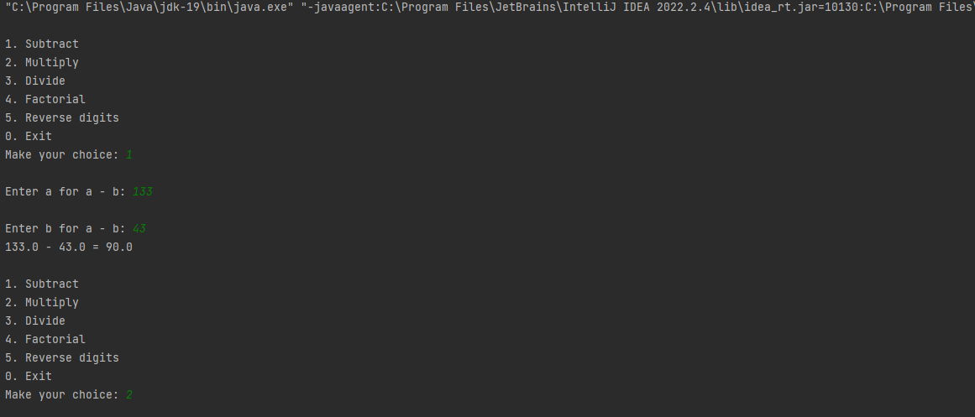

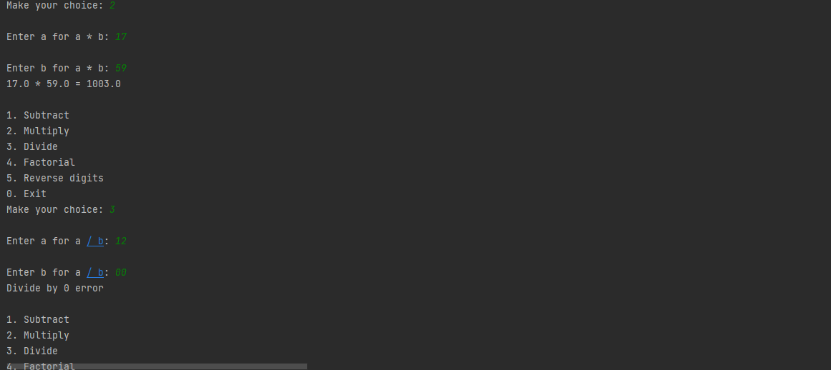

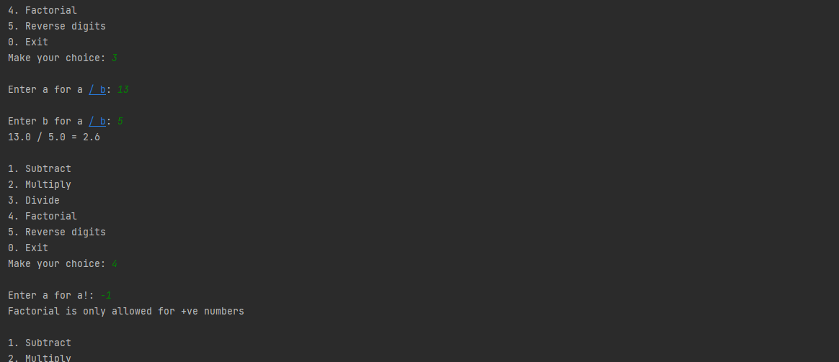

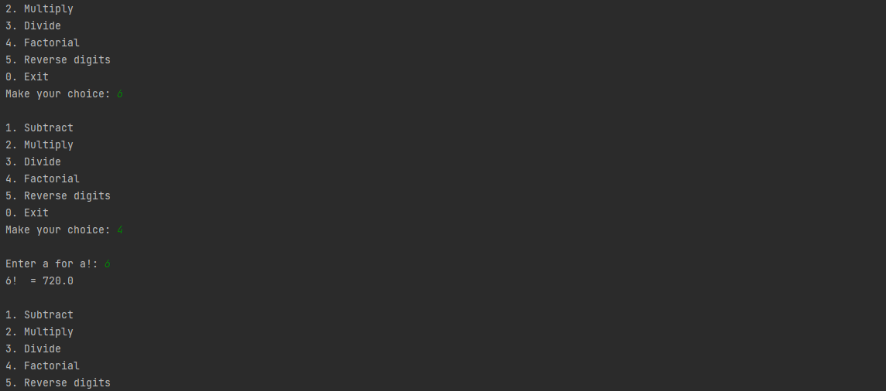

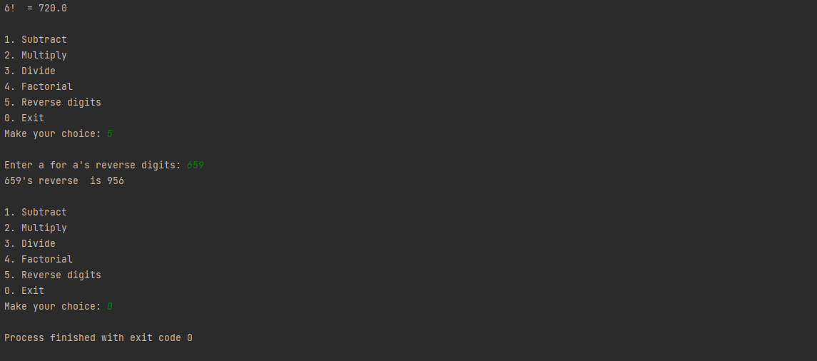

# Exception

## Write a program to demonstrate ArrayIndexOutOfBoundsException.

/*

Title:

Exception

Description:

Write a program to demonstrate ArrayIndexOutOfBoundsException.

Date modified; Author(s); Modification details

2022-12-28; abhinna; Created the program

*/

public class Q3Exception {

public static void main(String[] args) {

// creating an array of size 6 with values

int[] arr = {13, 22, 34, 84, 51, 60};

// running a loop of 10

for (int i = 0; i < 10; i++) {

// displaying array

// but, there may be exception so using try-catch block too

try {

System.out.println(arr[i]);

} // try

// catching Array Index Out Of Bounds Exception

catch (ArrayIndexOutOfBoundsException arrayIndexOutOfBoundsException) {

System.out.println("ArrayIndexOutOfBoundsException occurred" + arrayIndexOutOfBoundsException);

} // catch (ArrayIndexOutOfBoundsException arrayIndexOutOfBoundsException)

} // for (int i = 0; i < 10; i++)

} // public static void main(String[] args)

} // public class Q3Exception

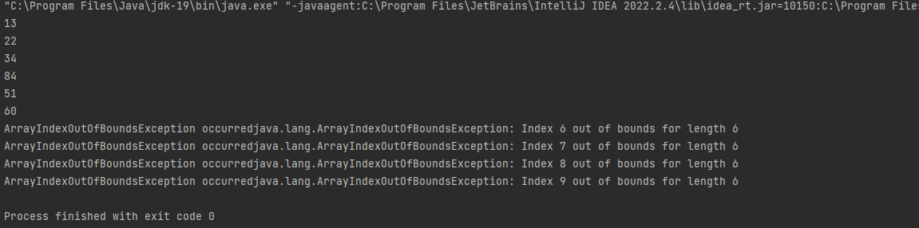

# Thread

## Write a program to print tables of 5 by creating a new thread and display 20 even numbers as a task of main thread.

/*

Title:

Thread

Description:

Write a program to print tables of 5 by creating a new thread and display 20 even

numbers as a task of main thread.

Date modified; Author(s); Modification details

2022-12-28; abhinna; Created the program

*/

public class Q4Threads {

public static void main(String[] args) {

// creating object of TableOf5 to pass onn thread

TableOf5 tableOf5 = new TableOf5();

// passing tableOf5 on Thread class to create a thread

Thread threadTable = new Thread(tableOf5);

// creating main thread to call the Table of 5 and display 20 even numbers

Thread mainThread = new Thread() {

// overriding run is must

@Override

public void run() {

int i = 0, even = 0;

// calling child thread from main thread

threadTable.start();

// printing 20 even numbers b first feeding an even number, then increasing it by 2

while (i < 20) {

System.out.println(even + " is even.");

i++;

even += 2;

// exception handling for Thread.sleep()

try {

// using Thread.sleep(300) to display at 0.3 second intervals for better output

Thread.sleep(300);

} // try

catch (InterruptedException e) {

throw new RuntimeException(e);

} // catch (InterruptedException e)

} // while (i < 20)

} // public void run()

}; // Thread mainThread = new Thread()

// starting main thread

mainThread.start();

} // public static void main(String[] args)

} // public class Q4Threads

// creating a runnable thread class by implementing Runnable interface

class TableOf5 implements Runnable

{

// overriding run method of Runnable interface

@Override

public void run() {

// print table of 5 from thread

for (int i = 1; i <= 10; i++) {

System.out.println("5 * " + i + " = " + (5 * i));

// exception handling for Thread.sleep()

try {

// using Thread.sleep(300) to display at 0.3 second intervals for better output

Thread.sleep(300);

} // try

catch (InterruptedException e) {

throw new RuntimeException(e);

} // catch (InterruptedException e)

} // for (int i = 1; i <= 10; i++)

} // public void run()

} // class Thread1 implements Runnable

